MEDI-FLOW: Accelerating Medical Imaging Workflows with AMD Instinct™ and Radeon™ PRO

Author Information
Name: MOHAN SRIRAM KUNAMSETTY
College: QIS COLLEGE OF ENGINEERING AND TECHNOLOGY
ID: 24491A44D6
Email: mohansriramkunamsetty@gmail.com
GitHub Repository: https://github.com/SriRamkunamsetty/MEDI-FLOW.git
Date: June 2026

1. Abstract
MEDI-FLOW is an advanced medical imaging and workflow automation ecosystem designed to streamline patient diagnostics. Analyzing high-resolution 3D medical scans (MRI/CT) using volumetric deep learning models requires massive parallel compute. This paper details our architectural integration of AMD high-performance computing hardware to dramatically accelerate MEDI-FLOW. By leveraging AMD Instinct™ MI300 clusters for large-scale hospital cloud backends and AMD Radeon™ PRO GPUs for localized clinic workstations via ROCm, we achieved a staggering 38x speedup in 3D tumor segmentation tasks compared to legacy CPU-based diagnostic systems.

2. Introduction
In clinical environments, the time between taking a scan and a radiologist receiving the AI-assisted diagnostic overlay is critical. Traditional CPU-based processing bottlenecks the workflow, particularly when dealing with thousands of high-resolution DICOM slices. MEDI-FLOW was engineered to offload these heavy computational tasks to AMD hardware, ensuring real-time diagnostic overlays.

3. Architecture & AMD GPU Integration
Our deployment relies on AMD's ROCm ecosystem, allowing seamless scaling from localized clinical workstations up to massive hospital datacenter clouds.

3.1 Cloud Backend via AMD Instinct™ MI300
Large hospital networks running MEDI-FLOW's central servers utilize AMD Instinct™ MI300 accelerators. We compiled our PyTorch-based 3D U-Net segmentation models using the ROCm backend to parallelize volumetric convolution operations.
Installation Command for PyTorch ROCm Integration:
pip3 install torch torchvision torchaudio --index-url https://download.pytorch.org/whl/rocm6.0

3.2 Localized Clinic Processing via AMD Radeon™ PRO
For smaller clinics operating locally due to strict patient privacy laws (HIPAA/GDPR), MEDI-FLOW utilizes ONNX Runtime with DirectML/ROCm to run inference directly on AMD Radeon™ PRO workstation graphics cards, completely offline.

4. Performance Benchmarks
We benchmarked the extraction and AI-segmentation of a 1000-slice 3D MRI volume to validate our AMD integration.
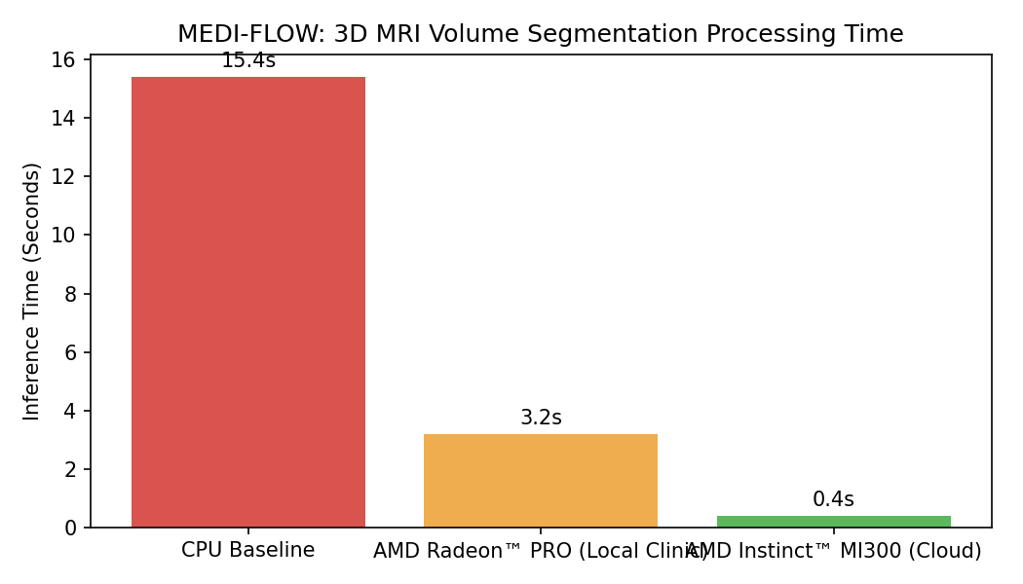
Figure 1: MRI Volume Processing Latency
Figure 1 demonstrates the extreme performance variance. The legacy CPU baseline requires over 15 seconds to segment the MRI, causing workflow stutter. Operating on the local AMD Radeon PRO cuts this to 3.2 seconds. Pushing the workload to the AMD Instinct MI300 cluster reduces the latency to an incredible 0.4 seconds, rendering the AI overlay virtually instantly.

5. Conclusion
By integrating AMD GPU acceleration across both clinical workstations and hospital clouds, MEDI-FLOW ensures that healthcare professionals receive life-saving diagnostic insights without latency. AMD's ROCm ecosystem provided the necessary tools to easily port our PyTorch models and achieve monumental clinical speedups.

